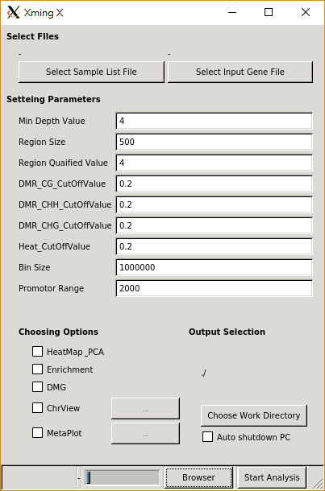

The overview of the tool’s GUI

1st step：select sample list file

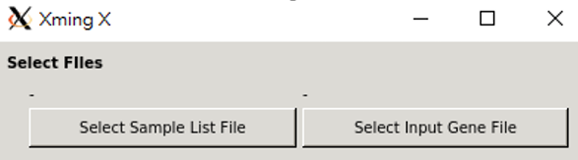

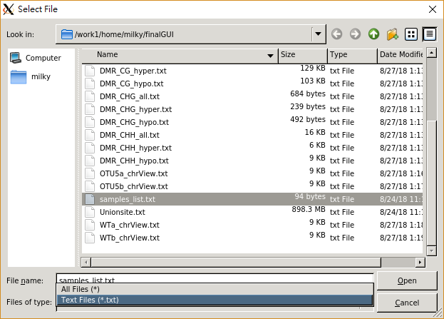

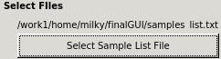

1. Push Select sample list file
2. Choose your sample list. You can use file filter to help you do this
3. When you selected sample list file, the label will change “-” to your sample list file path, and you can check it

2nd step：select input gene file



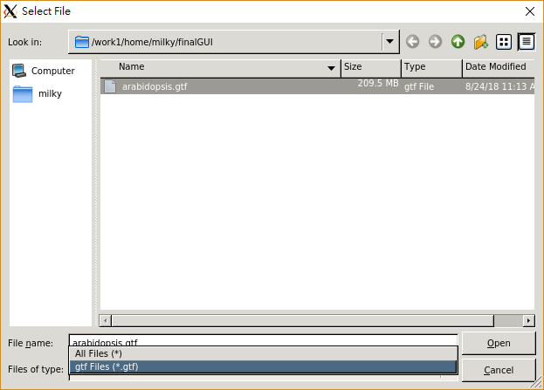



1. As same as select sample list

3rd step：setting parameters

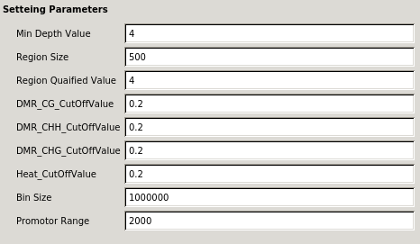

1. The default parameters is already set. You can modify it
2. If you confuse the mean of parameters, you can view the description document

4th step：Choosing which tools you want to use

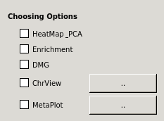

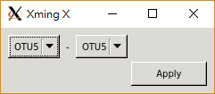

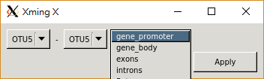

1. Check the box only
2. Chromosome view have a function that viewing the two group of samples mean methylation difference. So users who using this tool must set which group of samples mean minus which group of samples mean
3. Metaplot also have similar function. Other than this, metaplot also need user assign one genomic feature, so users can choose it through the combo box

5th step：setting output options

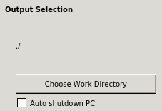

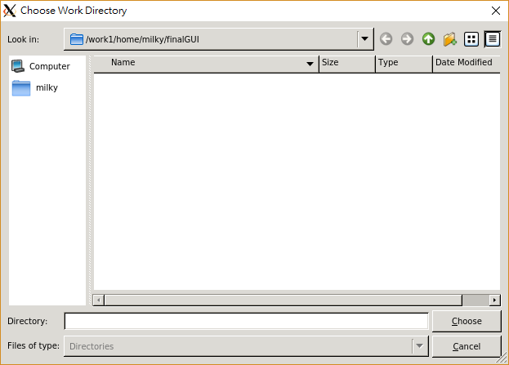

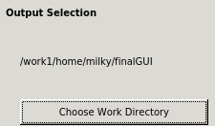

1. Setting the directory which you want output file save in it
2. After choosing directory, you can see this directory path on the label, and you can check it
3. If you want to sleep or do other things, you can choose the function auto shutdown PC, it will close your computer when analysis is complete. Using this function, you may check your permission first, if user have not enough permission, this function may not work

6th step：run it



1. When you start the analysis, there will show the instant progress at the bottom of window, so you can check the current progress in any time

7th step：View the analysis result



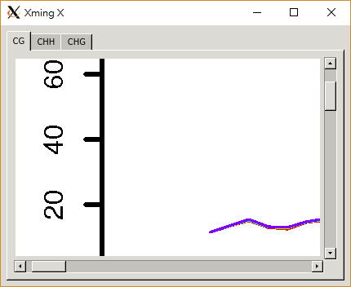

1. When analysis is done, you can use a simple bowser to view the report (figure)
2. The bowser classify reports by methylation type, so you can switch it through the list button
3. As same time, the report (output files) contain the non-figure report are totally save in the directory which you setting